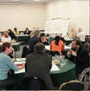
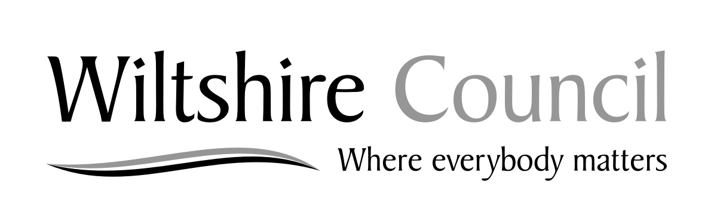
Is it a Board issue?
No
Yes
Refer to service
Issue logged
Yes
Resolved?
No
- Research
- Consultation
- Roundtables
- Options
Refer to Board
Resolved
& reported to Board
Issue received
Solution?
Yes
No
Resolved
& reported to Board
Refer to….
- Chairman
- Local Councillor
- Parish Council
- Service provider
- CAP
Is action
possible?
No
Yes
Issue closed
& reported to Board
AREA BOARDS
Dealing with your local issues

